- Copyright for test papers and marking guides remains with West Australian Test Papers.
- The papers may only be reproduced within the purchasing school according to the advertised conditions of sale.
- Test papers must be withdrawn after use and stored securely in the school until Wednesday 16th October 2013.
PHYSICS

YEAR 12

STAGE 3

2013

SOLUTIONS



Name: _______________________________________________________

Teacher: ___________________________________________________

TIME ALLOWED FOR THIS PAPER

Reading time before commencing work: Ten minutes
Working time for the paper: Three hours

MATERIALS REQUIRED/RECOMMENDED FOR THIS PAPER

To be provided by the supervisor:
- This Question/Answer Booklet; Formula and Constants sheet

To be provided by the candidate:
- Standard items: pens, pencils, eraser or correction fluid, ruler, highlighter.

- Special items: Calculators satisfying the conditions set by the Curriculum Council for this subject.

IMPORTANT NOTE TO CANDIDATES
No other items may be taken into the examination room. It is your responsibility to ensure that you do not have any unauthorised notes or other items of a non-personal nature in the examination room. If you have any unauthorised material with you, hand it to the supervisor before reading any further.

All calculations are to be set out in detail. Marks may be awarded for correct equations and clear setting out, even if you cannot complete the calculation. Express numerical answers to two (2) or three (3) significant figures and include units where appropriate. Express estimates to one (1) or two (2) significant figures, and state any assumptions clearly.
Structure of this paper

Section | Number of questions available | Number of questions to be answered | Suggested working time  (minutes) | Marks available | Percentage of exam
Section One:  Short answer | 13 | 13 | 50 | 54 | 30
Section Two:  Extended answer | 8 | 8 | 90 | 90 | 50
Section Three:  Comprehension  and data analysis | 2 | 2 | 40 | 36 | 20
 |  |  | Total | 180 | 100

Instructions to candidates

1. The rules for the conduct of Western Australian external examinations are detailed in the Year 12 Information Handbook 2013. Sitting this examination implies that you agree to abide by these rules.

2. Write answers in this Question/Answer Booklet.

3. You must be careful to confine your responses to the specific questions asked and follow any instructions that are specific to a particular question.

- Working or reasoning should be clearly shown when calculating or estimating answers. It is suggested that answers to calculations are given to 3 significant figures except when you are required to estimate. For estimation questions an appropriate number of significant figures must be stated.

5. Spare pages are included at the end of this booklet. They can be used for planning your responses and/or as additional space if required to continue an answer.
  - Planning: If you use the spare pages for planning, indicate this clearly.
  - Continuing an answer: If you need to use the space to continue an answer, indicate in the original answer space where the answer is continued, i.e. give the page number. Refer to the question(s) where you are continuing your work.

Section One: Short response 30% (54 Marks)

This section has 13 questions. Answer all questions. Write your answers in the space provided. Suggested working time for this section is 50 minutes.

Question 1
Classify the following spectra by circling two (2) of the options beneath each description:
- The flame of a burning candle
Emission Absorption Line Broadband Continuous ✓
- Light shining from a mercury vapour lamp
Emission Absorption Line Broadband Continuous ✓
- Light after white light was passed through a solution of Potassium Permanganate
Emission Absorption Line Broadband Continuous ✓
(3)
Question 2

A charged particle enters a region between 2 parallel charged plates. The potential difference between the plates is 455 V. The electric field strength in the region between the charged plates is 6.50 × 10⁴ V m⁻¹.
Positive plate
Negative plate
Charged Particle
Distance
- Calculate the distance between the plates.
(2)
V = 455 V E = 6.50 x 10⁴ V m⁻¹

E = V / d
d = V / E = 455 / 6.50 x 10⁴ ✓
d = 7.00 x 10⁻³ m (7.00 mm) ✓

- The charged particle experiences a force of magnitude 3.12 ×10⁻¹⁴ N that causes it to deflect towards the positive plate. Determine the charge of the particle.
F = 3.12 ×10⁻¹⁴ N E = 6.50  10⁴ V m⁻¹

E = F / q
q = F / E = 3.12 ×10⁻¹⁴ / 6.50 x 10⁴ ✓
q = -4.80 x 10⁻¹⁹ C ✓ Negative ✓
(3)

Question 3






Rail falling at 25.0 m/s within magnetic field
An iron rail of mass 150 kg and length 4.22 m is falling at 25.0 m s⁻¹ next to a magnetic pole of a large electro-magnet in a breakers yard. The magnetic flux density of the electro-magnet is 840 mT and its direction is indicated in the diagram.

- Calculate the potential difference across the length of the rail.
(2)
l = 4.22 m v = 25.0 m/s B = 0.840 T
emf = lvB = 4.22 x 25.0 x 0.840 ✓
emf = 88.6 V ✓

- Explain, referring to charge location, how a potential difference is established in this situation.
(2)
Electrons are forced to the left hand side of the rail. ✓
This establishes a region of negative charge at the left and a region of positive charge at the right. ✓

Question 4
For particles travelling at near light speeds in a particle accelerator, more force is required to maintain a constant acceleration as the speed of the particle increases.

- Explain why this is the case.
According to special relativity as an object approaches near light speed its mass increases. ✓ a = F / m so if mass increases, force must increase to maintain acceleration ✓
(2)

- If the particle is radioactive, explain what happens to the value of its half-life when viewed from a stationary frame of reference as it accelerates.
(2)
According to special relativity time is moving at a slower rate on moving object ✓ so half-life increases. ✓

- If the particle is radioactive, explain what happens to the value of its half-life when viewed from its own frame of reference.
(1)
No change, as stationary in its own frame of reference. ✓

Question 5
By banking the curves of racetracks it is possible for vehicles to turn in a horizontal circle without relying on friction. For a car of mass 2100 kg the angle of banking is set at 16.0° above the horizontal. The car drives at a speed 24.0 m s⁻¹ to maintain its height on the bank.

Vector diagram
ΣF

16.0°
Normal Reaction
Weight
= mg
16º

- Draw a vector diagram in the space above showing the forces acting on the car and the sum of those forces.
(1)

- Calculate the horizontal radius of the car’s path.
ΣF = mv²/r

tan 16º = (mv²/ r) / (mg) ✓
tan 16º = (v²/ gr)
r = v² / g.tan 16º ✓
r = 24² / 9.8.tan 16º
r = 205 m

✓
(3)

- The speed of the car increases to greater than 24.0 m s⁻¹. Explain what other change must occur if the magnitude of forces on your vector diagram remain the same on this frictionless track.
(2)
If ΣF = mv²/r is fixed ✓then as v increases the radius must increase as well. ✓ 
(The car will move to a position higher up the track)

Question 6
The diagram shows a DC electric motor. A square coil of one turn is rotating about an axle. The current is 0.40 A. The direction of current in the lengths of the coil next to each magnetic pole is indicated on the diagram. The scale of the diagram is the actual size of the motor. A uniform magnetic field of 86 mT exists between the magnetic poles.

S

N
⊗
·
Axle

- Place arrows on the diagram to indicate the direction of magnetic force on each length of wire shown carrying current. as above
(1)

Estimate the magnitude and direction of torque due to the length of wire next to the South magnetic pole at the instant shown.
By measurement: lever arm = 0.017 m angle = 70º length = 0.034 m (as square) – allow some tolerance
From question, I = 0.40 A B = 0.086 T N = 1 ✓
T = r.F.sinθ F = BIlN so T = rBIlNsinθ
T = 0.017 x 0.086 x 0.40 x 0.034 x 1 x sin 70º ✓
T = 1.9 x 10⁻⁵ N m anticlockwise (sig figs matches min used) ✓
(3)

Question 7
A roller coaster car of mass 700 kg is upside down whilst doing a ‘loop the loop’. The radius of the loop is 12.0 m. Calculate the speed required at the top of the loop for the car to experience a normal reaction force of 5000 N from the track. You must refer to a vector diagram in your answer.
Roller coaster track
Roller coaster car
Weight = mg
= 700  9.8
= 6860 N

ΣF
N = 5000 N

(4)
Vector diagram ✓
r = 12.0 m m = 700 W = mg = 6860 N ✓

∑F = 5000 + 6860 = 11860 N
mv²/r = 11860 N
v = ((11860 x 12 / 700))^{0.5} ✓
v = 14.3 m/s ✓

Question 8
The following table of data applies to a transformer that is ideal in terms of voltage but only 90.0 % efficient due to current losses. Fill in the data for the blank cells. There is space below the table to show your working.
(4)
 | Primary Winding | Secondary Winding
Number of turns | 480 turns | 288 turns
Voltage | 240 V | 144 V ✓
Current | 0.300 A ✓ | 450 mA
Power | 72.0 W ✓ | 64.8 W ✓
V_{s}/V_{p} = N_{s}/N_{p} V_{s} = (N_{s}  V_{p}) / N_{p} = 144 V ✓

P_{s} = V_{s} x I_{s} = 144 x 0.45 = 64.8 W ✓

P_{p} = P_{s}/0.9 = 72.0 W ✓

I_{p} = P_{p} / V_{p} = 72 / 240 = 0.30 A ✓

✓

Question 9
Galaxy NGC 3351 is in the constellation of Leo. It is a distance of 11.7 megaparsecs from Earth. One parsec equals 3.26 light-years. A light-year is the distance travelled by light in one year. Calculate the distance to NGC 3351 in kilometres.
(4)
Distance (ly) = 11.7  10⁶  3.26 = 38 142 000 ly ✓

1 ly in metres = s x t = 3 x 10⁸ x 365 x 24 x 60 x 60
1 ly = 9.4608 x 10¹⁵ m ✓

Distance to NGC 3351 = distance (ly) x 9.4608 x 10¹⁵
Distance to NGC 3351 = 38 142 000 x 9.4608 x 10¹⁵
Distance to NGC 3351 = 3.61 x 10²³ m ✓
Distance to NGC 3351 = 3.61 x 10²⁰ km ✓

Question 10
Two loudspeakers are set up outside and both emit a single frequency sound in phase. A person walking along a line parallel to the loudspeakers notices that the intensity of sound varies between loud and quiet.
Loudspeaker
Loudspeaker
Person walks along this line
Use physics principles to explain why there are loud regions and quiet regions in this situation.
(4)
In some locations the sound waves from each speaker are arriving in phase. ✓ This leads to constructive interference and sound is heard as pressure fluctuates.✓

In some locations the sound waves from each speaker are arriving out of phase by half a wavelength. ✓ This leads to destructive interference and no sound is heard as pressure is constant.✓

Question 11
The line emission spectra observed from elements in distant stars can be compared to line emission spectra from the same elements in a laboratory. Explain what differences between the two spectra are likely to be seen and from this, what information can be deduced about the stars that can be applied to Hubble’s Law.
The spectral lines from the distant star will have the same pattern but the wavelength will be shifted to be longer for each line. (Redshift)✓ This indicates that the source of the waves (the star) is moving away relative to the Earth. ✓ From the amount of redshift the recessional speed of the source can be determined. ✓ Hubble’s Law relates the recessional speed to the distance to the source. ✓
OR – this indicates that the universe is expanding, OR indicates that Universe originated from Big Bang. Any 4 well linked points.
(4)

Question 12

- There are six flavours of quarks (normal matter version). These are detailed in the table.
Determine the charge of the following particles that are made from quarks:
Quark | Charge
Up (u) | +e
Down (d) | -e
Charmed (c) | +e
Strange (s) | -e
Top (t) | +e
Bottom (b) | -e

Xi-plus (dss) -1 (1)

Kaon- minus (s) -1 (1)

Note: refers to an anti up quark

b. Neutrinos we believe travel at the speed of light and have negligible mass. Experiments suggest the mass is very small and is usually stated in terms of its energy equivalent in electron volts. Most experiments conclude that the mass equivalent of the neutrino is less than 50 eV. Determine the mass of neutrinos in kg. (Hint E=mc²) (2)

E = 50x1.6x 10⁻¹⁹J
E= 8.0 x 10⁻¹⁸J ✓

M= 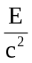
M = ✓ 8.89 X 10 ⁻³⁵ kg

Question 13
Two identical magnets are fixed in position on a flat bench. A compass is placed near the magnets.

- Sketch the magnetic field in the region around the magnets. Draw at least 4 field lines for each magnet.
(2)
N S
S N
Compass
- Indicate the direction that the compass needle will point by placing an arrow in the circle.
(1)

End of Section One

Section Two: Problem-solving 50% (90 Marks)

This section has eight (8) questions. You must answer all questions. Write your answers in the space provided. Suggested working time for this section is 90 minutes.

Question 14 (13 marks)

A physics student observes a stone of mass 450 g being catapulted from the top of a cliff. The launch position at the top of the cliff is 6.00 m above ground level. The stone lands 20.0 m in front of the launch position. The initial launch speed u is at an angle of 40.0° to the horizontal. You may ignore air resistance for the calculations.

6.00 m
20.0 m
Cliff
40°
Initial launch speed u

- Calculate the initial launch speed u of the stone. You must show clear algebraic steps in your solution.

Hint: consider the flight time for both the horizontal and vertical components of motion.
(5)
Consider the total flight time t_{f}
s_{y} = -6.00 u_{y} = u.sin 40 a_{y} = -9.80 m/s² ✓
u_{x} = s_{x} / t_{f} u.cos 40 = 20 / t_{f} ∴ t_{f} = 20/u.cos40 ✓

s_{y} =u_{y} t_{f} + ½ a_{y} t_{f}²
-6 = 20(u.sin 40/u.cos 40)-((4.9x20²)/(u²cos²40) ✓
-6 = 20(tan 40)-(3340.02/u²)
-6 = 16.78199 – 3340.02/u²
-22.7819 = -3340.02/u²
u² = 3340.02 / 22.7819 ✓
u² = 146.6
u = 12.1 m/s ✓

- Calculate the flight time of the stone. (If you were not able to solve part a), use a numerical value of 12.1 m s⁻¹ for the initial launch speed u).
(3)
u = 12.1 m/s s_{x}= 20.0 m θ = 40° u_{x} = u.cos 40 ✓

u_{x} = s_{x} / t_{f}

t_{f} = 20/(12.1 x cos40) ✓

t_{f} =2.157698 t_{f} = 2.16 s ✓

- Calculate the minimum value of kinetic energy of the stone whilst in flight. (If you were not able to solve part a), use a numerical value of 12.1 m s⁻¹ for the initial launch speed u).
(2)
This occurs at the top of the flight when the there is no vertical component of velocity.
m = 0.450 kg
speed = u.cos 40 = 9.269 m/s

KE = ½ m v² = ½ 0.45 x 9.269² ✓ = 19.3 J ✓

- Calculate the maximum height above ground level that the stone reaches on its flight path. (If you were not able to solve part a), use a numerical value of 12.1 m s⁻¹ for the initial launch speed u).
(3)
when v = 0 u = 12.1 x sin 40° = 7.77773 m/s up
a = -9.80 m/s² s = ?

v² = u² +2as
0 = 7.77773² –(19.6 x s) ✓

s = 7.77773²/19.6 = 3.086 m above launch ✓
above ground = 3.086 + 6.00 = 9.09 m ✓

Question 15 (13 marks)

The diagram below details some of the energy levels for a fictitious atom, Michellium.
Ground state E1
E2
E3
E4
E5
E∞
-9.76 eV
-5.65 eV
-3.18 eV
-1.96 eV
-1.34 eV
zero eV

- Calculate the minimum photon energy in joules that could ionise the atom in its ground state.
(2)
Minimum energy (J) = 9.76 x 1.60 x 10⁻¹⁹ ✓
Minimum energy (J) = 1.56 x 10⁻¹⁸ J ✓

- Calculate the longest wavelength (nm) possible in the emission spectrum of Michellium as the ionised atom returns to its ground state.
(3)
Longest wavelength = shortest transition
Shortest transition = 1.96 -1.34 = 0.62 eV

0.62 eV = 0.62 x 1.60 x 10⁻¹⁹ J = 9.92 x 10⁻²⁰ J ✓

E = hf = h.c / λ

λ = h.c / E = 6.63 x 10⁻³⁴ x 3 x 10⁸ / 9.92 x 10⁻²⁰ ✓
λ =2.005 x 10⁻⁶ m = 2.01 x 10⁻⁶ m ✓

- For the wavelength you calculated in part b. state which area of the electromagnetic spectrum this belongs to.
(1)
infra-red ✓  (2.01  10⁻⁶ / 10⁻⁹ = 2010 nm )

- Is it possible for a Michellium atom to absorb a 4.21 eV photon? Explain briefly.
(2)

No – there is no energy level difference that corresponds to 4.21 eV. ✓ A photon will only transform all or none of its energy. ✓

- An atomic electron is at E5. How many lines in the emission spectrum would be possible for the energy levels considered above if it returns to the ground state? Indicate them on the diagram.
(1)
Number of lines = 10 ✓

- A single Michellium atom in the ground state is bombarded by one electron with a kinetic energy of 6.78 eV. Detail in the table below the possible photon energies observable on de-excitation and the possible bombarding electron energies after passing through the Michellium atom.
(4)
Possible photon energies on de-excitation (eV) | Possible bombarding electron energies after passing through the Michellium atom (eV)
Calculate -9.76 + 6.78 = -2.98 eV ∴ max excitation to E3 ✓  -5.65 – (-9.76) = 4.11 eV (E2 to E1)  -3.18 – (-9.76) = 6.58 eV (E3 to E1)  -3.18 – (-5.65) = 2.47 eV ( E3 to E2) ✓ | 6.78 – 4.11 = 2.67 eV ( after excitation E1 to E2)✓  6.78 – 6.58 = 0.20 eV (after excitation E1 to E3) ✓  May also state  (0 - 6.78 eV = 6.78 eV (misses))
- ½ mark for any missing / extra

Question 16 (10 marks)

The 400 kg boom of a crane is pivoted at point A. The length of the uniform boom AC is 8.00 m. A crate of mass 700 kg is lifted by a rope attached at C. A flexible cable is attached at point B where the length AB is 6.00 m. The cable makes an angle of 22º with the boom. The rope lifting the crate makes an angle of 110º with the boom.

Crate 700 kg
Boom 400 kg
Cable
A
B
C
22º
110º

- Demonstrate by calculation that the tension in the cable is 2.95 x 10⁴ N
(4)
ΣM = 0 Σacwm = Σcwm M = r.F.sinθ
AC = 8.00 m AB = 6.00 m θ_{B} = 22° θ_{C} = 110° ✓
Take moments from A

6F_{tension}sin 22° ✓
= 4 x 400 x 9.8 x sin 110° + 8 x 700 x 9.8 x sin 110° ✓

F_{tension} =
(4 x 400 x 9.8 x sin 110° + 8 x 700 x 9.8 x sin 110°)/(6 x sin22)

F_{tension} = 66304.711 / 2.24763956
F_{tension} = 29499.70 = 2.95 x 10⁴ N ✓

- Construct a vector diagram (approximately to scale) to show that ΣF = 0 when considering the weight of the boom, the weight of the crate, tension in the cable and reaction force from the pivot.
(2)
Reaction Force
θ = 180 –(110+22) = 48° ✓

F_{tension} = 29499.70 W = (700+400) x 9.8 = 10 780 N
48° ✓

- Calculate the magnitude of the reaction force from the pivot.
(2)
θ = 180 –(110+22) = 48°

By Cosine Rule

✓

R = 23682.58 = 2.37  10⁴ N ✓

✓

- Calculate the direction of the reaction force relative to the vertical and show this angle on your vector diagram (note that the force acts below the horizontal).
By Sine rule 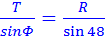

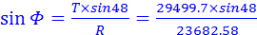 ✓

Φ = 67.77 or 112.23°
Must correspond to angle shown on diagram. ✓
(2)

Question 17 (12 marks)

A rectangular coil is placed in the uniform magnetic field between 2 magnetic poles such that the plane of the coil is always perpendicular to the field lines. The coil has dimensions of 16.0 cm by 10.0 cm and is made from 75 turns of wire. The magnetic field has a flux density of 75.0 mT. The coil is quickly removed from the magnetic field. The graph shows the area of the coil in the field (expressed as a percentage) versus time, whilst the coil is removed.

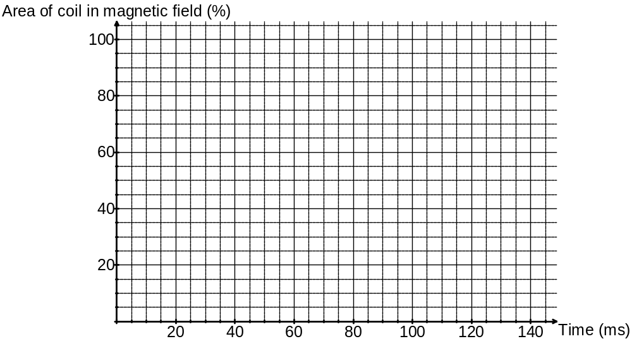

- Calculate the magnetic flux enclosed by the coil when it is fully within the magnetic field.
(2)
Φ = B.A = 0.075 x 0.16 x 0.10 ✓ = 1.20 x 10⁻³ Wb ✓

- Calculate the average value of induced emf between the times of 40 milliseconds and 100 milliseconds.
(4)
Evidence of working from the graph:
Φ₁ = 0.85 x 1.20 x 10⁻³ Φ₂ = 0.20 x 1.20 x 10⁻³ ✓
t = (100 – 40) ms = 60 x 10⁻³ s ✓

emf = -N (Φ₂ - Φ₁) / t

emf = -75 (-0.65 x 1.20 x 10⁻³) / 60 x 10⁻³ ✓
emf = 0.975 V ✓

- How does the magnitude of induced emf from 120 ms to 140 ms compare with your previous answer? Explain briefly, no calculation is required.
(2)
The gradient is less steep; therefore the rate of change of flux is less. ✓ This means emf is less. ✓

.
The diagram below shows the rectangular coil being removed from the magnetic field.

- Show the direction of induced current as the coil is moved to the right. Draw an arrow on the coil to indicate current direction and label it ‘current’. Briefly explain your answer.
(2)
Coil is removed from the magnetic field
As the diagram ✓ By Lenz’s law current flows to establish its own field to oppose the change in field.✓
Or similar.

The rectangular coil is then fixed on an axle, placed back in the uniform field and rotated at a uniform rate of 750 rpm. A graph showing emf voltage versus time is shown.

- Using the same axes, sketch the approximate shape of an emf graph if the rate of rotation is changed to 375 rpm.
Period double ✓
Amplitude ½ ✓

(2)
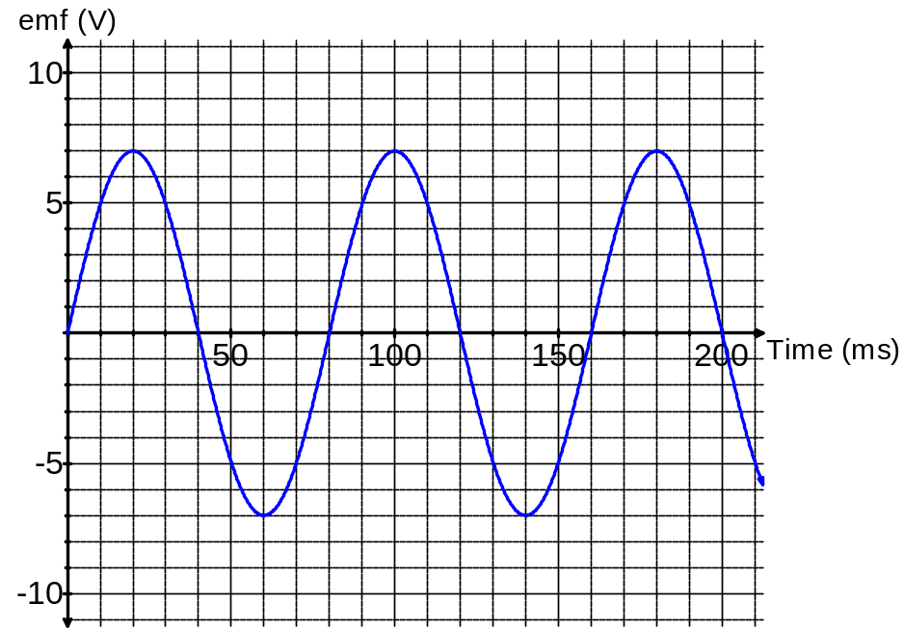

Question 18 (13 marks)
A binary planet system consists of two planets orbiting around their common centre of mass. This location is known as the barycentre. A binary planet system is shown below. Planet Talus has a mass of 2.04 x 10²⁵ kg, Planet Trebor has a mass of 5.44 x 10²⁴ Kg. The total separation between the 2 planets is always 210 500 km and the barycentre always lies on a straight line between Talus and Trebor, The distance between each planet and the barycentre is detailed in the diagram below (not to scale).

Talus
Trebor
44 300 km
166 200 km
barycentre
New positions

- Calculate the gravitational force of attraction between Talus and Trebor.
(3)
r = 44 300 000 + 166 200 000 = 210 500 000 m
M₁ = 2.04 x 10²⁵ kg M₂ = 5.44 x 10²⁴ Kg
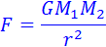
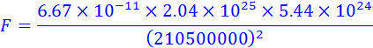

- Calculate the speed of Talus around the barycentre.
(3)
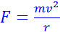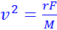

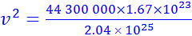 

v = 602.2989 = 6.02 x 10² m/s✓

- Calculate how many Earth hours it takes for Talus to orbit the barycentre.
(2)
T = 2πr/v = 2π44 300 000 / 602.2989 ✓

T = 462 137.77 s = 462 137.77/(6060) = 128 hours ✓

- Estimate the position of the planets after 32 hours of time from the initial position shown. Sketch them on the diagram and label them. Talus orbits in a clockwise direction about the barycentre. (If you could not determine the previous answer use 128 hours)
(2)
32 / 128 = ¼ of a revolution. ✓

Show on diagram ✓

- Show by algebraic proof that the following relationship must be true for any binary planet system that rotates around a barycentre in the pattern described in this question.
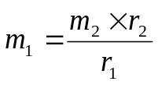
m₁ = mass of planet 1 (kg) m₂ = mass of planet 2 (kg)
r₁ = distance of planet 1 to barycentre (m)
r₂ = distance of planet 2 to barycentre (m)

Common centripetal force F
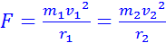 substitute 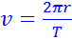 ✓

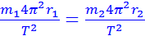 Common period T✓

Divide out common terms

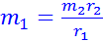 ✓

(3)

Question 19 (16 marks)

Some students are investigating resonance in an air column. They use a large measuring cylinder as a pipe closed at one end and fill it with different amounts of water to set the length of the pipe.
Length of cylinder
c = end correction
Loudspeaker
Standing wave envelope
Measuring
Cylinder
Water
They perform an experiment to determine the speed of sound in air. A loudspeaker at the top of the cylinder is set at different frequencies by musical notes from a synthesiser and then the water level is varied until resonance occurs at the fundamental frequency.
The students found it difficult to set the length at the resonant frequency so decided to record this data with an uncertainty of ±10%.
One quarter of a standing wave forms in the tube at the fundamental frequency for a given length.
The effective length of tube is just beyond the actual length of the tube so the students derived the following expression:
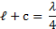
Where, = the length of the air column (m) and c = the end correction (m)
They manipulate this expression to get the following equation that shows the relationship between frequency and length in a y = mx + c format.
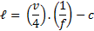
Where, v = speed of sound (m s⁻¹) f = frequency of sound (Hz)
The results obtained were as follows:
Note | Frequency (Hz) | 1/f (s) | Length (m)
D3 | 147 | 0.00680 | 0.508 ± 0.051
F3 | 175 | 0.00571 | 0.415 ± 0.042
A3 | 220 | 0.00454 | 0.340 ± 0.034
D4 | 294 | 0.00344 | 0.210 ± 0.021
G4 | 392 | 0.00255 | 0.147 ± 0.015
B4 | 494 | 0.00202 | 0.102 ± 0.010

Answer the following questions:

- Complete the third column of the table (1/f) so that you can plot a graph where the gradient of the line of best fit produced is equal to an average value of (v/4). One of the values has been done for you. values ✓ format ✓ as per table
(2)

- Complete the fourth column of the table (Length) including the uncertainty in the measurement. Two values have been done for you. ✓ as per table
(1)

- Plot a graph of length against 1/f using error bars to indicate uncertainty. You must allow your y-axis to have a range of values from -0.100 m to +0.600 m. You must allow your x-axis values to have a range from zero to +0.007.

If you need to make a second attempt, spare graph paper is at the end of this question. Indicate clearly if you have used the second graph and cancel the working on the first graph.
(5)

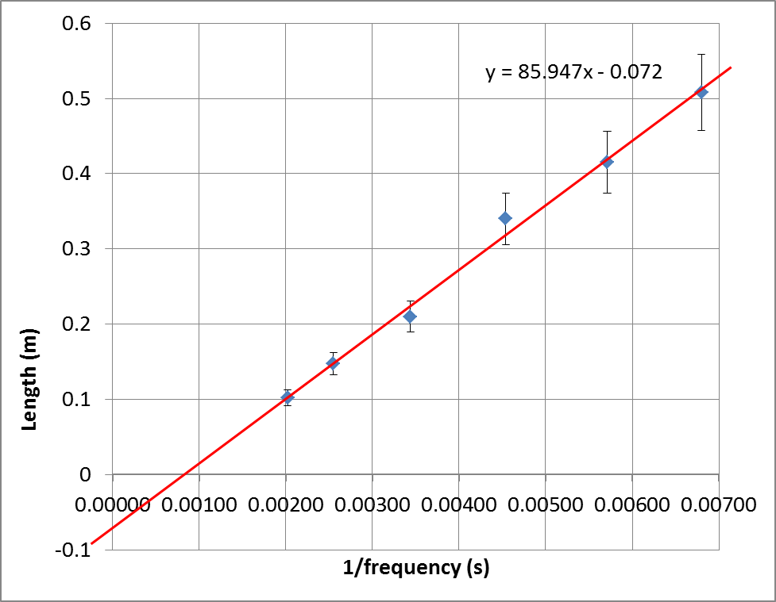

- Calculate the gradient of your line of best fit from your graph showing all working.
(3)

Clearly show rise and run construction lines on the graph✓

gradient = 0.53/0.0062 ✓= 85.4 m/s ✓

- Determine the speed of sound from the value of the gradient that you obtained. (If you could not determine the gradient use the numerical value 80.0).
(3)
Gradient = average value of v/4
85.4 = v/4
v = 85.4 x 4 = 342 m/s ✓

- From your graph determine what the end correction (c) is for this air column. Show clearly on your graph how you obtained this value.
(2)
Clearly show intercept on y-axis on graph ✓
c = 0.072 m (allow some tolerance+- 0.010) ✓

✓

Spare graph paper


(3)

Question 20 (7 marks)

Ionised atoms of magnesium (Mg²⁺) are doubly charged positive ions. They each have a mass of 3.98 10⁻²⁶ kg. They are accelerated through an electric field between charged parallel plates before entering a vacuum chamber where they are deflected by a magnetic field.

Magnesium ions
Vacuum Chamber
Charged plates
Ion Accelerator
Deflection in magnetic field
-  

-  

-  

-  

- Calculate the potential difference between the charged plates in the Ion Accelerator that will give the magnesium ions a maximum velocity of 1.33 × 10⁵ m s⁻¹
(3)
W = V.q ΔKE = V.q ½ m v² = V.q (if u = 0)

q = +3.20 x 10⁻¹⁹ C ✓

½ x 3.98 x10⁻²⁶ x (1.33 × 10⁵) ² = V. +3.20 x 10⁻¹⁹ ✓
V = 1100 V ✓

- Indicate on the diagram, the direction of the magnetic field within the vacuum chamber that will cause the deflection shown. Indicates    out of page ✓
(1)

- The magnetic flux density within the chamber is set to 98.0 mT. Calculate the radius of the circular path followed by a magnesium ion travelling at 1.33 × 10⁵ m s⁻¹.
(3)
F_{centripetal} = qVB (concept✓)

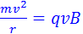 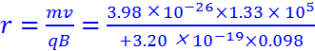✓
r = 0.169 m ✓

Question 21 (6 marks)

The diagram shows a guitar string that is plucked to form the standing wave envelope shown. The note heard has a frequency of 587.3 Hz. The string is in tension between the two fixed bridges and has a length of 648 mm.
Bridge
Bridge
Length of string = 648 mm
AN
AN
AN

- Calculate the wave speed along the string that leads to the formation of this standing wave.
(3)

λ = 2/3 of 0.648 = 0.432 m f = 587.3 Hz ✓

v = f.λ = 587.3 x 0.432 ✓= 253.7136 = 254 m/s ✓

- Identify all the particle displacement antinodes by labelling them ‘AN’ on the diagram.
(1)
As diagram above ✓

- Calculate the frequency produced by the string if it were vibrating in its fundamental mode.
(2)
At fundamental length = λ / 2 0.648 = λ / 2
λ = 1.296 ✓

f = v / λ = 253.7136 / 1.296 = 196 Hz ✓

End of Section 2
Section Three: Comprehension 20% (36 Marks)

This section contains two (2) questions. You must answer both questions. Write your answers in the space provided. Suggested working time for this section is 40 minutes.

Question 22 The application of ultrasound for medical imaging (18 marks)

Ultrasound is high frequency sound waves above the upper limit for human hearing. Ultrasound in medical imaging is produced by a transducer that uses a piezoelectric crystal. An alternating voltage applied across the crystal causes it to vibrate and send out a pulse of sound waves. The applied voltage is removed to allow the crystal to detect any reflections. Reflected pulses received after a time delay vibrate the crystal and generate a current which can give information about the distance to the point of reflection. The transmit/receive cycle can be repeated thousands of times per second.

The reflection of ultrasound is used to observe structures within the human body. Imaging with an ‘Amplitude Modulated’ scan can be used to measure distances within the body (e.g. the diameter of the torso). A ‘Brightness Modulated’ scan can provide a two dimensional outline image of a feature within the body e.g. stones in a gall bladder.

Reflection occurs when an ultrasonic pulse passes across an interface between two media - for example soft tissue and bone. Some of the energy and intensity of the ultrasonic pulse is reflected as a result of the fact that the two media will have different 'acoustic impedances’. This is shown in Figure 1.

Equation 1. The acoustic impedance Z of a medium is defined by: Z = ρ × v_{sound}
ρ = density of medium (kg m⁻³), v_{sound} = speed of sound in the medium (m s⁻¹)

Medium 1
Medium 2

Incident intensity I_{i}
Transmitted intensity I_{t}

Reflected intensity I_{r}

Z₁ = ρ₁ × v₁
Z₂ = ρ₂ × v₂

Figure 1: Reflection of ultrasound at an interface

Values of density and speed of ultrasound in different media are shown in the table.

Material | Density  ( × 10³ kg m⁻³) | Speed of ultrasound  (m s⁻¹)
Air | 0.0013 | 330
Bone | 1.91 | 4080
Brain | 1.03 | 1540
Fat | 0.952 | 1450
Muscle | 1.08 | 1580
Soft tissue | 1.06 | 1540
Water | 1.00 | 1500
Equation 2:
The fraction α_{r} of the intensity reflected is given by: 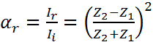

I_{i} = incident intensity within medium 1,
I_{r} = intensity reflected back into medium 1 at the boundary between medium 1 and medium 2

If α_{r} = 1, then 100% of the incident energy is reflected. If α_{r} = 0, then none of the incident energy is reflected. As long as α_{r} is greater than 40%, then a ‘Brightness Modulated’ scan should produce an excellent outline image of a feature within the body.

Answer the following questions

- What type of ultrasound scan would be used to give an image of a developing foetus in a pregnant lady?
(1)
Brightness Modulated ✓

- Calculate the minimum time gap that should be left between pulses emitted by the transducer if ultrasound is reflected from a depth of 7.00 cm and travels only in soft tissue.
(3)
s = 0.07 × 2 = 0.14 m v_{sound} = 1540 m/s ✓

v = s / t
t = s / v = 0.14 / 1540 ✓
t = 9.09 × 10⁻⁵ seconds ✓

✓

- Demonstrate by calculation that the acoustic impedance of ‘air’ = 429 kg m⁻² s⁻¹
(2)
Z = ρ × v_{sound}
Z = 1.30 × 10⁻³ × 10³ × 330 ✓ from table
Z = 429 kg m⁻² s⁻¹ ✓

- Demonstrate by calculation that the acoustic impedance of ‘soft tissue’ = 1.63 × 10⁶ kg m⁻² s⁻¹.
(2)
Z = 1.06 × 10³ × 1540 from table ✓
Z = 1 632 400 kg m⁻² s⁻¹
Z = 1.63 × 10⁶ kg m⁻² s⁻¹ ✓

✓

- A student attempts to perform an ultrasound scan directly onto the stomach of a pregnant lady. The ultrasound must travel through a small air gap before going into the soft tissue of the patient’s stomach. Calculate the fraction α_{r} of the intensity reflected at the air-soft tissue interface and explain why an image of the foetus cannot be formed.
(3)
α_{r} =[ (Z₂ – Z₁) / (Z₂ + Z₁) ]²
α_{r} = [ (1 632 400 – 429) / (1 632 400 + 429) ]²
α_{r} = 0.999 (99.9%)

all signal is reflected back from surface before entering the patient ✓

- The student tells her teacher that she cannot get an image. The teacher advises her to smear a “coupling gel” onto the patient’s stomach to exclude all air between the transducer and the soft tissue of the patient. The “coupling gel” has the same acoustic impedance as soft tissue. Explain the reason for using a “coupling gel”.
(3)
If Z₂ = Z₁ then α_{r} = (0 / 2Z)² = 0 ✓ reflection = 0% ✓

Which means practically 100% transmission of ultrasound into the patient ✓

✓

- The acoustic impedance of bone is Z_{bone} = 7.79 × 10⁶ kg m⁻² s⁻¹. Demonstrate by reference to a calculation that reflections at the soft tissue-bone interface will give a good image of the skeleton of a developing foetus.
(4)
α_{r} =[ (Z₂ – Z₁) / (Z₂ + Z₁) ]²

α_{r} = [ (7.79 × 10⁶-1 632 400 ) / (7.79 × 10⁶ +1 632 400 ) ]² ✓

α_{r} = 0.427 (42.7%) ✓

This is greater than 40% ✓
Which means it will produce an excellent outline ✓

Question 23 From Orbits to Energy Levels (18 marks)

The work of Michael Faraday led James Clark Maxwell to develop a theory about the origin of electromagnetic waves. In 1864 Maxwell predicted that any accelerated charged particle should generate an electromagnetic wave. In 1887 Heinrich Hertz verified Maxwell’s theory. By causing electrons to accelerate back and forth in a wire loop he generated an electromagnetic wave. The radio waves coming from the loop were detected by a second wire loop on the other side of his laboratory. Worldwide radio communication was developed from this discovery.

Rutherford proposed his model of the atom in 1911 to supersede JJ Thomson’s “plum pudding model”, of 1904. Rutherford envisaged distant electrons following circular orbits around a central positively charged nucleus much like the planets in a solar system orbit a star. The problem with this planetary model is that according to classical Physics any mass that is undergoing circular motion is by definition experiencing a force to give it centripetal acceleration. If this were the case then the electrons would be sending out electromagnetic waves, which would reduce their energy and so send them spiralling into the nucleus. This is not the case and called for a further refinement to the atomic model.

In 1913 Niels Bohr proposed what is now called the Bohr model of the atom. He suggested that electrons could only have certain motions:
- The electrons travel in orbits that have discrete quantized speeds, and therefore quantized energies. That is, not every orbit is possible but only certain specific ones, at certain specific distances from the nucleus.
- The electrons do not continuously lose energy as they travel. They can only gain or lose energy by jumping from one allowed orbit to another.

What made Bohr’s hypothesis brilliant was the derivation of formulae that predicted the radius of the energy levels and the values of the energy levels for the hydrogen atom. These predictions were later verified by experimental data.

Bohr derived the following formula using high school level algebra. The energy level value for electrons in the hydrogen atom is given by:

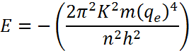

E = energy level value (J)
K = Coulombs constant = 9.00 × 10⁹ N m² C⁻²
m = mass of electron (kg)
q_{e} = the charge on an electron (C)
n = the energy level number (1, 2, 3….)
h = Planck’s constant

In 1900 Max Planck had introduced the idea that light is only delivered in quantum amounts. The ‘photon’ model fitted well with Bohr’s energy level model where the energy of an emitted photon given by E = h.f, must match the difference in energy level values (joules) in a de-excitation between energy levels.

In 1924 the French aristocrat Louis de Broglie (pronounced ‘broy’) was able to solve the dilemma that electrons seemed to violate some of the basic principles of classical physics. In a doctoral thesis he introduced the idea that particles have wave characteristics in the same way that light waves have particle characteristics.

By linking the Einstein equation E = mc² and the Planck equation E = h.f, De Broglie derived an equation for the wavelength λ (m) of any particle of mass m (kg), travelling at a speed v (m s⁻¹) :

The De Broglie equation for wavelength of a particle: 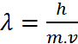

Diffraction of electrons through a crystalline solid by GP Thomson demonstrated by experiment the wave nature of matter suggested by De Broglie. The principle that electrons also behave like waves is used in the tunnelling electron microscope to produce clear images of objects that are too small for conventional microscopes.

De Broglie showed that the circumferences of the Bohr energy levels are exactly whole integer multiples of the electron wavelengths. So an electron wavelength fits the circumference a whole number of times leading to an electron standing wave through reinforcement. The ground state is like the “fundamental frequency” and excited states are like the “harmonics” in mechanical standing waves.

The piecemeal quantisation of Physics by Planck, Bohr, Einstein and others was successful but disjointed.

Further work by Schrödinger, Born, Pauli and Dirac led to our current understanding of electron orbitals (regions around the nucleus in which there is a high probability of finding an electron at any given instant).

Questions

- Rutherford’s planetary model of the atom was considered flawed. Explain why.
(2)
The electron charges are accelerating in circular orbits ✓, so according to Heinrich Hertz accelerating charge radiates energy, which would lead to energy of electrons decreasing.✓ This is not the case. ✓

✓

- What type of experimental data could have verified Bohr’s energy level values for the hydrogen atom?
(2)
Line emission spectrum from hydrogen ✓
Using E = hf to confirm energy level differences from measured frequencies. ✓
Or similar valid explanation

✓

- The formula 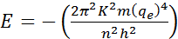 can be simplified to, 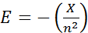

Calculate the numerical value of X, showing all working and stating your answer in scientific notation.
(3)
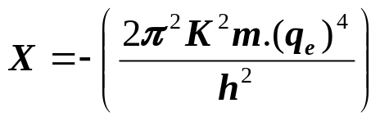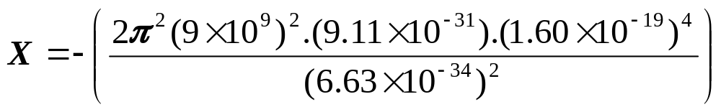 ✓ ✓
X = 2.17 × 10⁻¹⁸ J ✓

- In terms of energy in electron volts the formula in part c) may also be written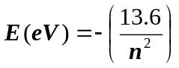

Use this formula to calculate the energy level values for hydrogen for n = 1, 2, 3 and 4 (2)

Energy Level Number | Energy level value (eV)
4 | -0.85
3 | -1.51
2 | -3.40
1 | -13.6

- How did the work of Louis de Broglie link back to the predictions of Niels Bohr?
(2)
It confirmed the circumferences of Bohr energy levels ✓

Circumference is based on radius which Bohr predicted. ✓

✓

- Use the De Broglie equation for wavelength of a particle to calculate the wavelength of a cricket ball of mass 250 g bowled at 20 m s⁻¹ and explain why it is hard to observe wave motion of a cricket ball along its projectile path.
(3)
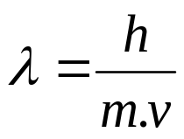 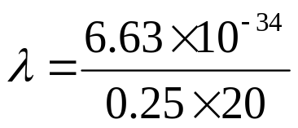✓

λ = 1.33 × 10⁻³⁴ m ✓
Very small so difficult to measure ✓

- How is a De Broglie electron orbit similar to a guitar string that has been plucked?
(2)
Principle of standing waves, a guitar string vibrates as a standing wave, electron orbits seem to reinforce like standing waves. ✓ ✓
Or words to that effect.

- What is the fundamental difference between a conventional microscope and a tunnelling electron microscope?
(2)
Conventional microscope uses light behaving as a wave ✓
Electron microscope uses electrons behaving like waves ✓

End of questions

